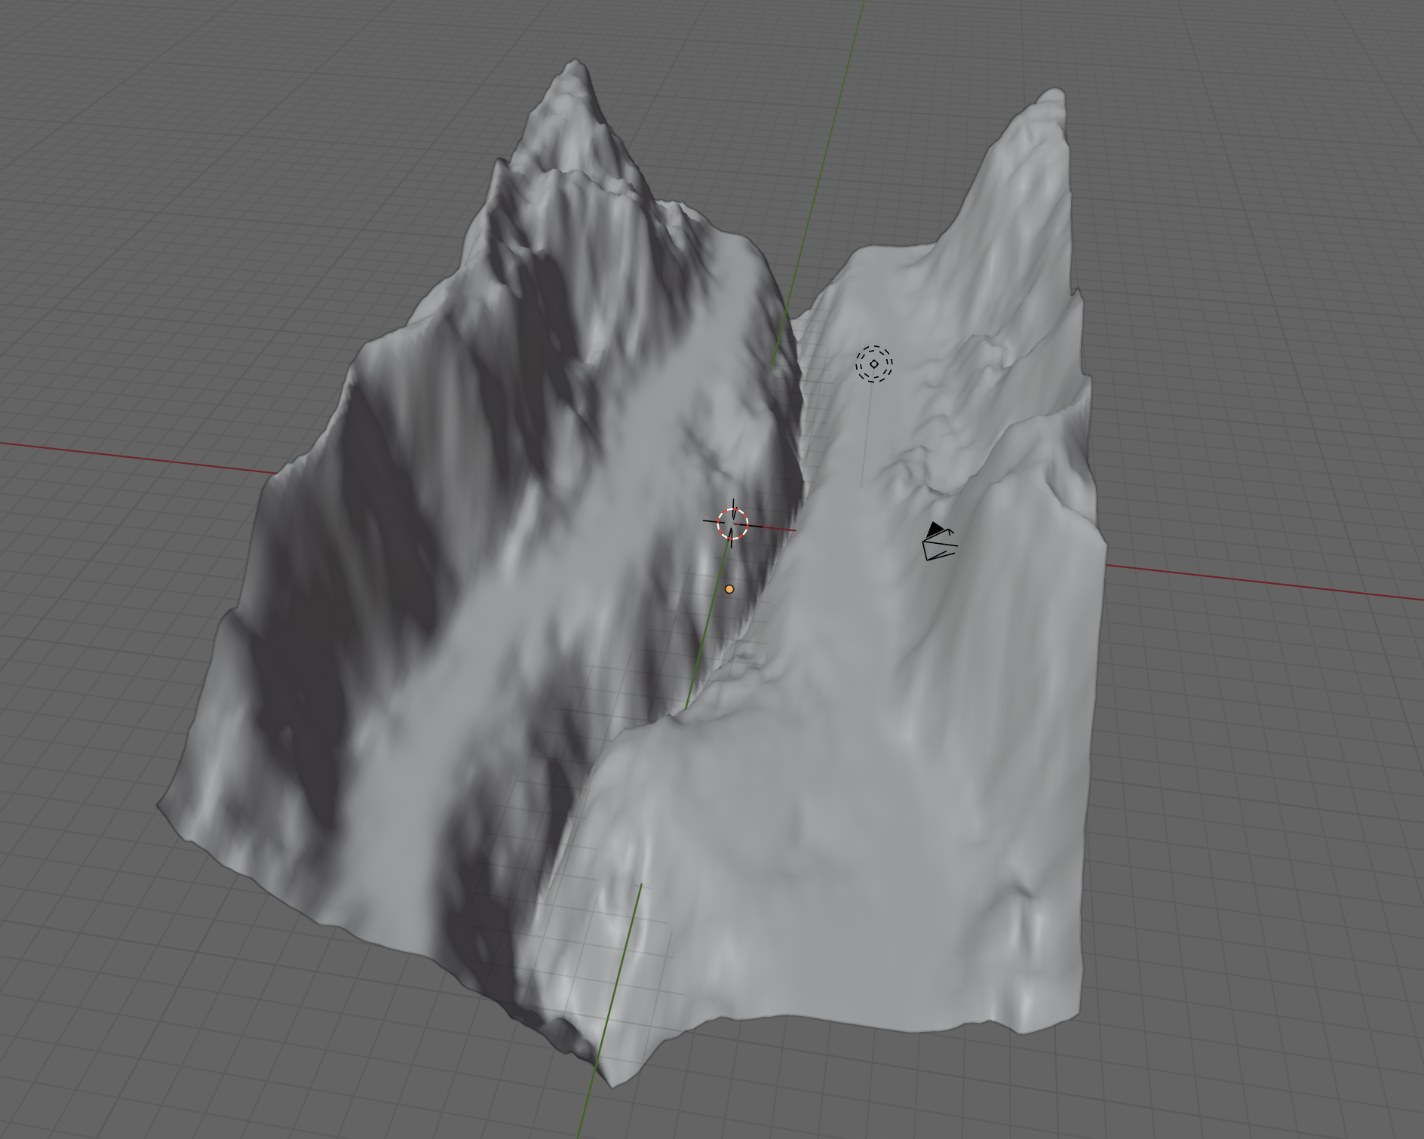
River Valley
Mountain Range
Plain

